Name: Shubham Sharma
Batch: 1
SAP ID: 590014710

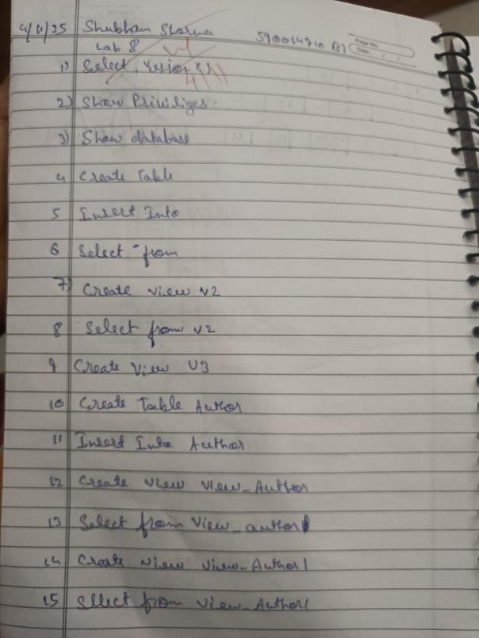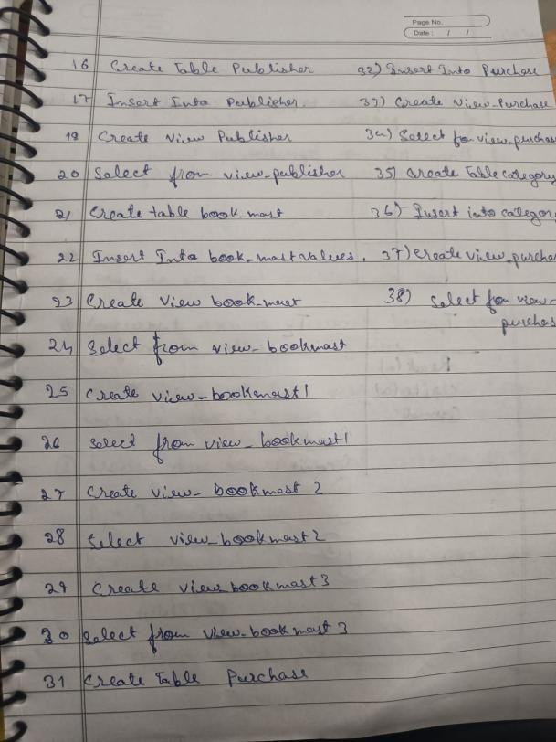

Queries:
- To check the version of the database server:
SELECT VERSION();
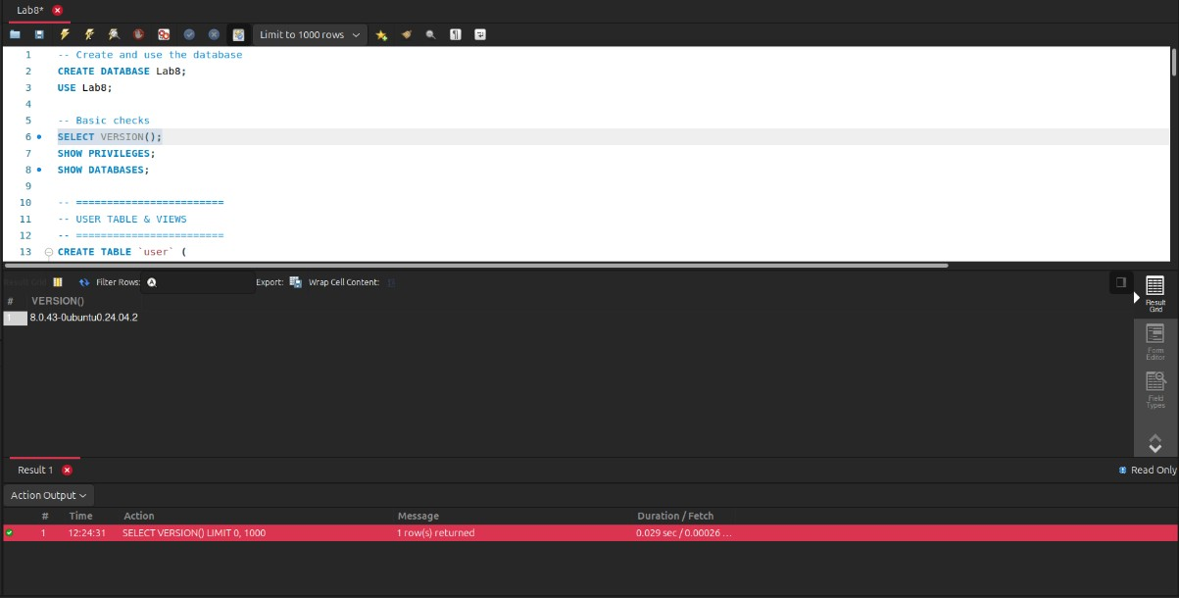
- To show the privileges of the current user:
SHOW PRIVILEGES;
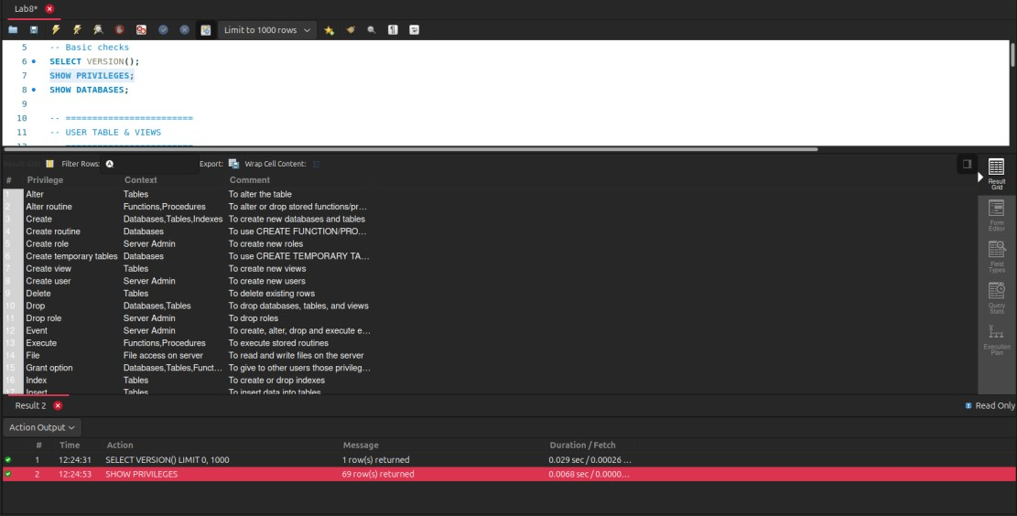

- To show the list of databases:
SHOW DATABASES;
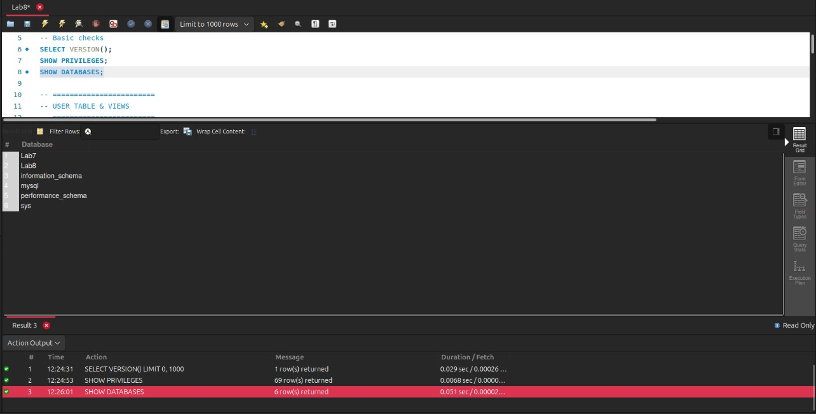
- Create View CREATE TABLE user ( userid VARCHAR(50) PRIMARY KEY, password VARCHAR(50), name VARCHAR(50)
);
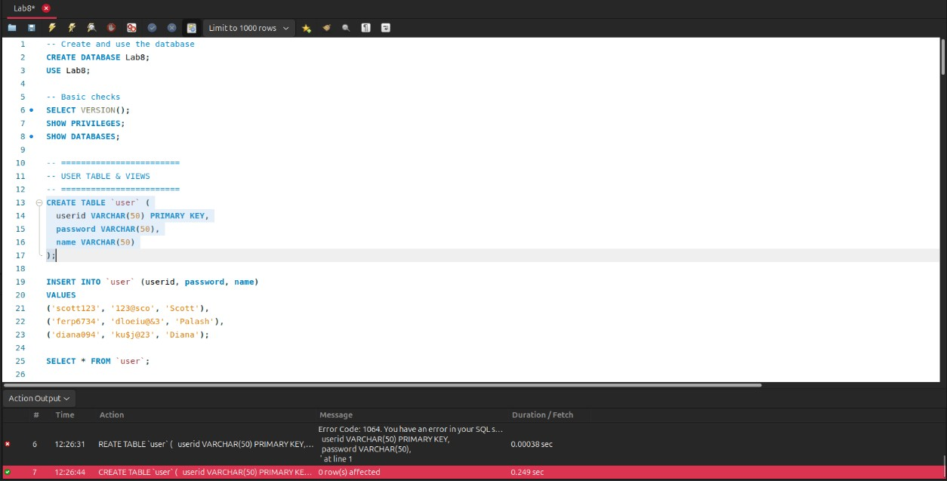

5.
INSERT INTO user (userid, password, name)
VALUES
('scott123', '123@sco', 'Scott'),
('ferp6734', 'dloeiu@&3', 'Palash'),
('diana094', 'ku$j@23', 'Diana');
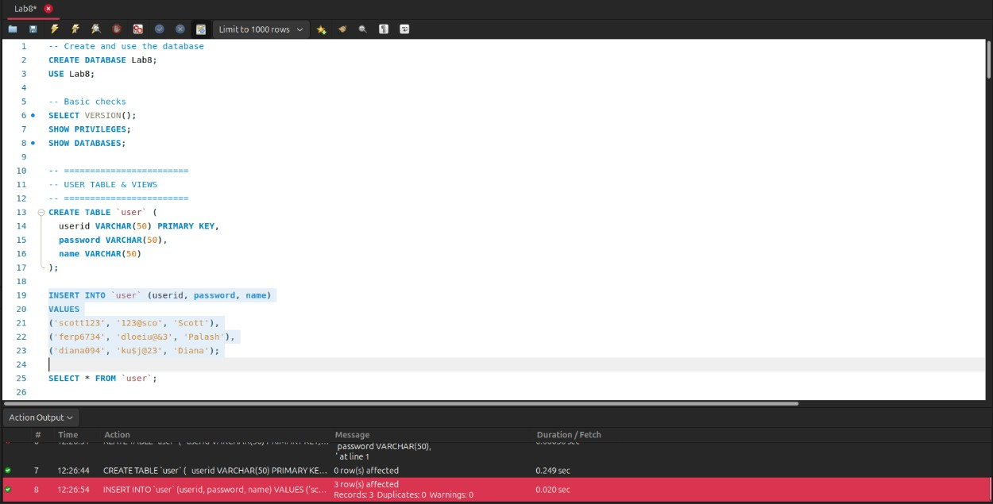
6.
SELECT * FROM user;
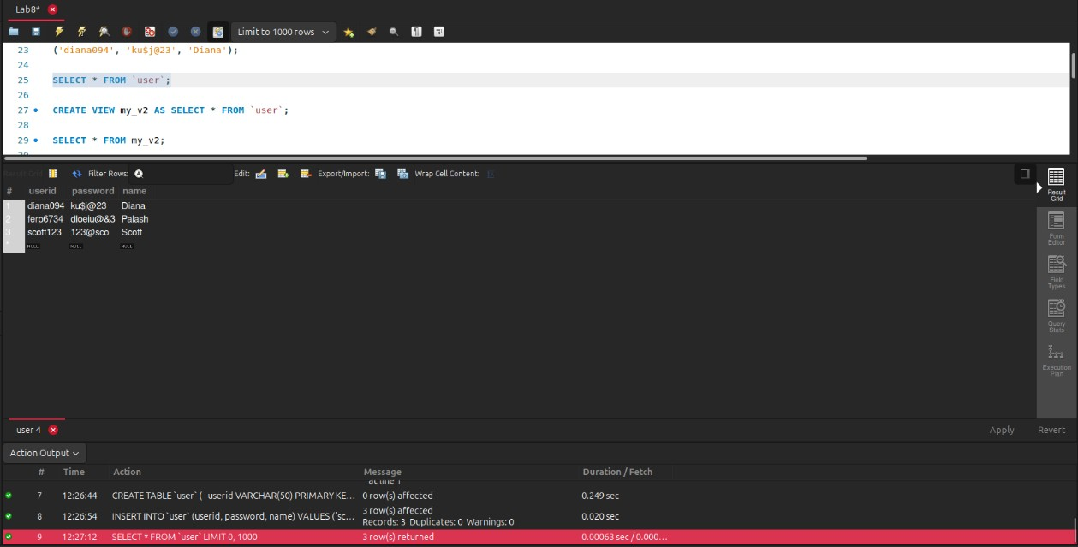
7.
CREATE VIEW my_v2 AS SELECT * FROM user;
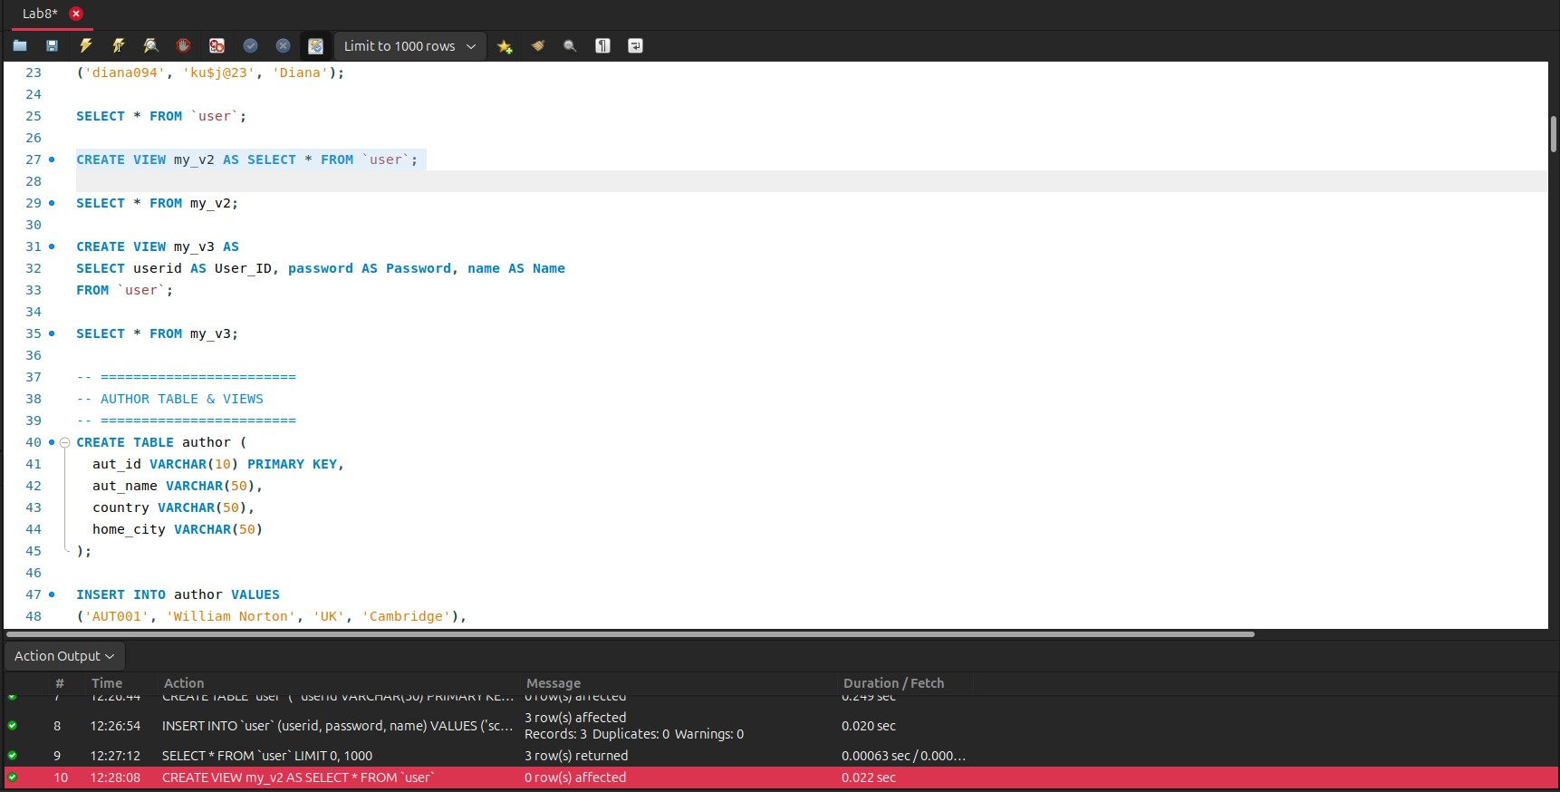

8.
SELECT * FROM my_v2;
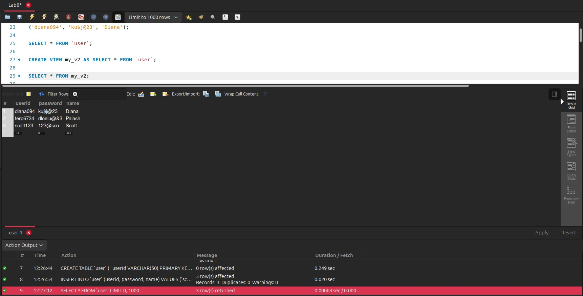
9.
CREATE VIEW my_v3 AS SELECT userid AS User_ID, password AS
Password, name
AS Name FROM user;
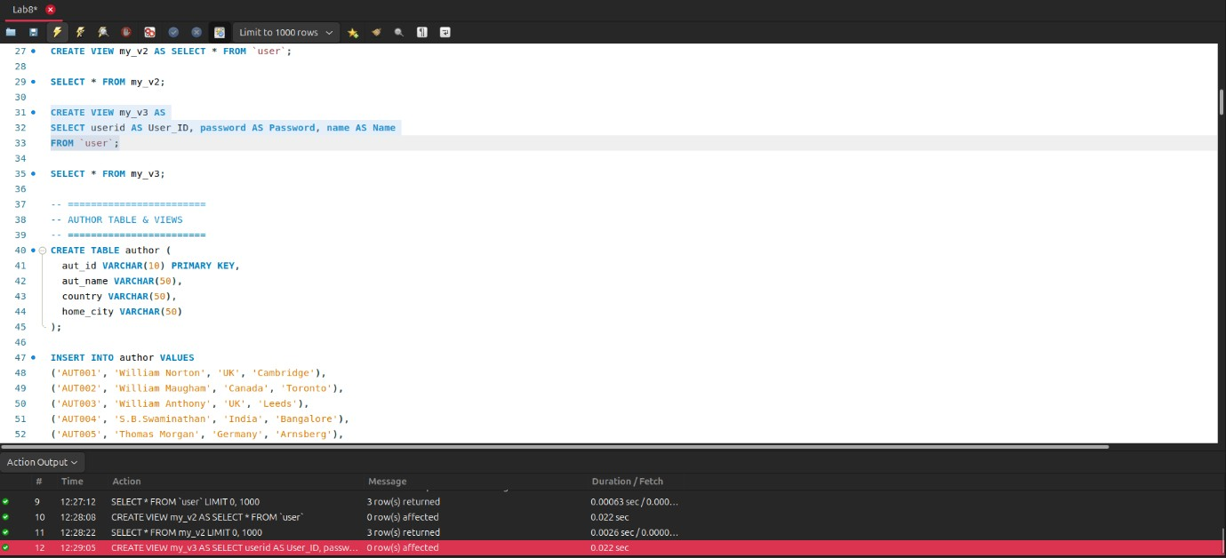
10.
SELECT * FROM my_v3;
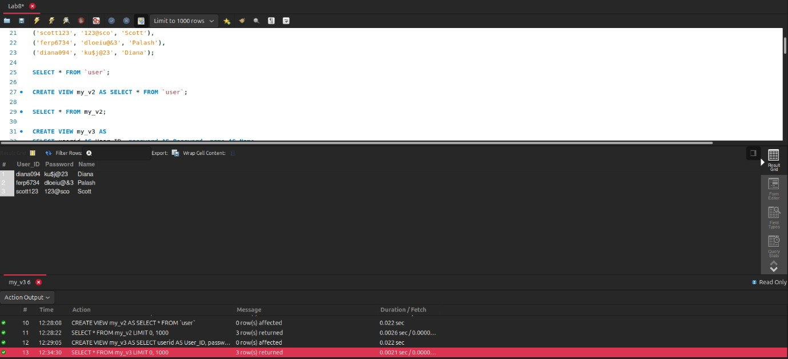
11. CREATE VIEW with WHERE CREATE TABLE author ( aut_id VARCHAR(10) PRIMARY KEY, aut_name VARCHAR(50), country VARCHAR(50), home_city VARCHAR(50)
);
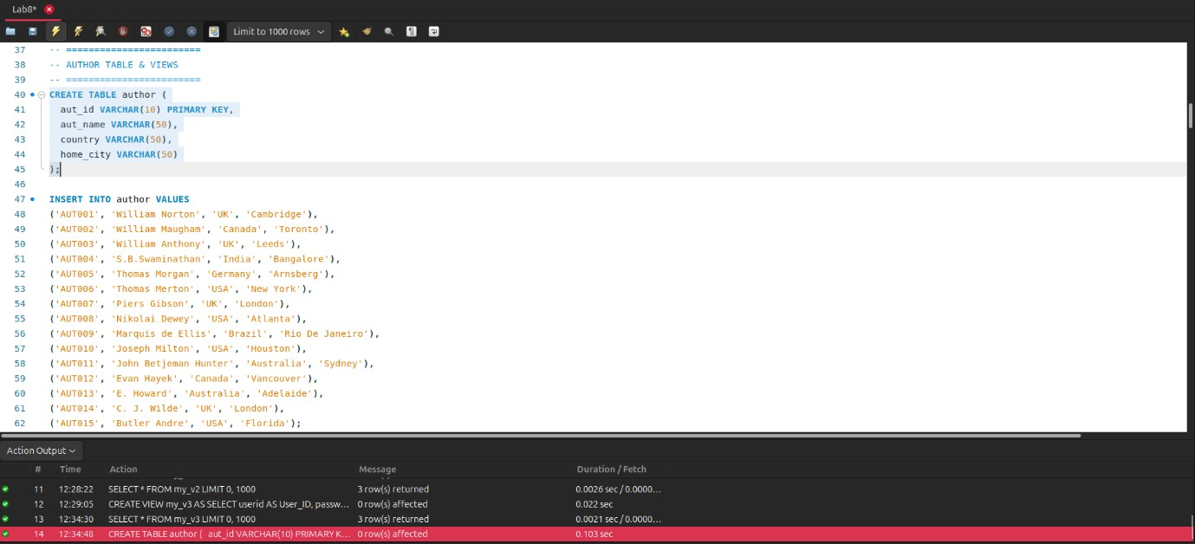
12.
INSERT INTO author (aut_id, aut_name, country, home_city)
VALUES
('AUT001', 'William Norton', 'UK', 'Cambridge'),
('AUT002', 'William Maugham', 'Canada', 'Toronto'),
('AUT003', 'William Anthony', 'UK', 'Leeds'),
('AUT004', 'S.B.Swaminathan', 'India', 'Bangalore'),
('AUT005', 'Thomas Morgan', 'Germany', 'Arnsberg'),
('AUT006', 'Thomas Merton', 'USA', 'New York'),
('AUT007', 'Piers Gibson', 'UK', 'London'),
('AUT008', 'Nikolai Dewey', 'USA', 'Atlanta'),
('AUT009', 'Marquis de Ellis', 'Brazil', 'Rio De Janeiro'),
('AUT010', 'Joseph Milton', 'USA', 'Houston'),
('AUT011', 'John Betjeman Hunter', 'Australia', 'Sydney'),
('AUT012', 'Evan Hayek', 'Canada', 'Vancouver'),
('AUT013', 'E. Howard', 'Australia', 'Adelaide'),
('AUT014', 'C. J. Wilde', 'UK', 'London'),
('AUT015', 'Butler Andre', 'USA', 'Florida');
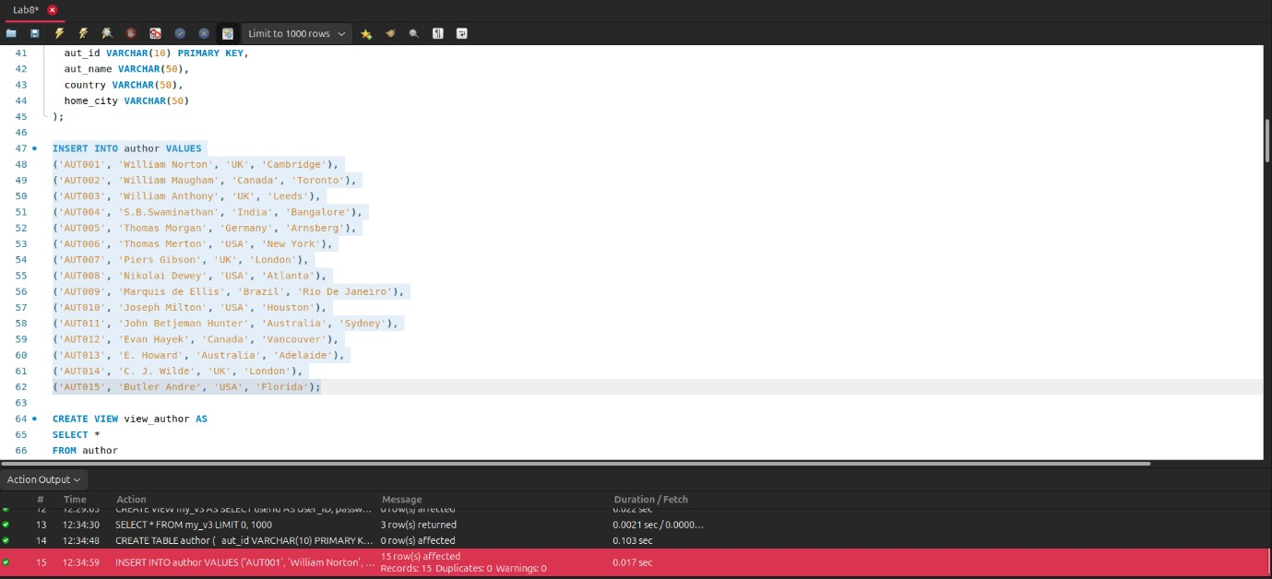
13.
CREATE VIEW view_author
AS SELECT *
FROM author
WHERE country='USA';
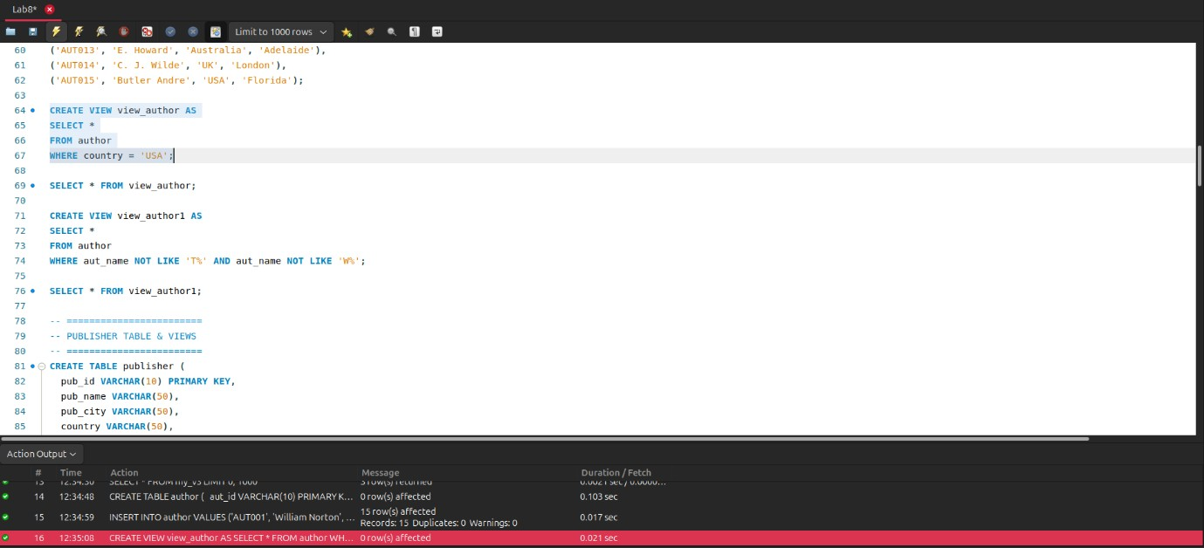
14.
SELECT * FROM view_author;
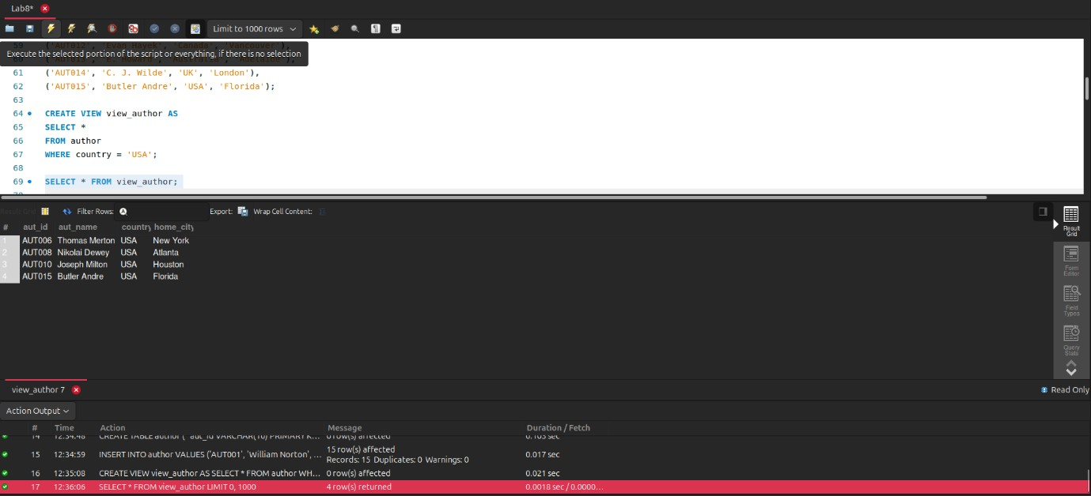
15. CREATE VIEW with AND and OR CREATE TABLE publisher ( pub_id VARCHAR(10) PRIMARY KEY, pub_name VARCHAR(50), pub_city VARCHAR(50), country VARCHAR(50), country_office VARCHAR(50), no_of_branch INT, estd DATE
);
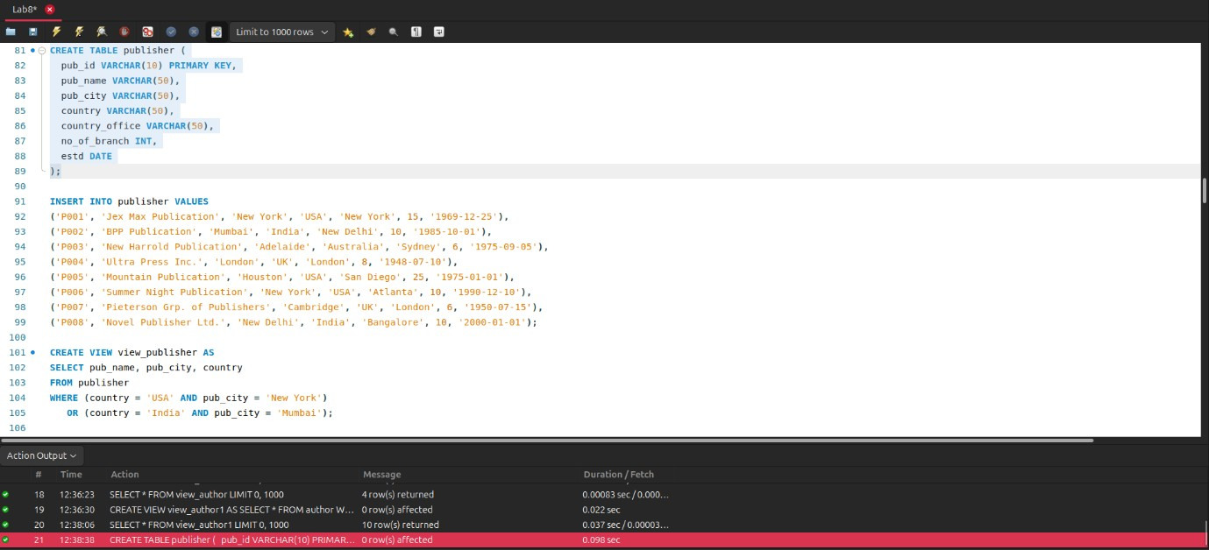
16.
INSERT INTO publisher (pub_id, pub_name, pub_city, country, country_office, no_of_branch, estd)
VALUES
('P001', 'Jex Max Publication', 'New York', 'USA', 'New York', 15, '1969-12-25'),
('P002', 'BPP Publication', 'Mumbai', 'India', 'New Delhi', 10, '1985-10-01'),
('P003', 'New Harrold Publication', 'Adelaide', 'Australia', 'Sydney', 6, '197509-05'),
('P004', 'Ultra Press Inc.', 'London', 'UK', 'London', 8, '1948-07-10'),
('P005', 'Mountain Publication', 'Houstan', 'USA', 'Sun Diego', 25, '1975-0101'),
('P006', 'Summer Night Publication', 'New York', 'USA', 'Atlanta', 10, '1990-1210'),
('P007', 'Pieterson Grp. of Publishers', 'Cambridge', 'UK', 'London', 6, '195007-15'),
('P008', 'Novel Publisher Ltd.', 'New Delhi', 'India', 'Bangalore', 10, '2000-0101');
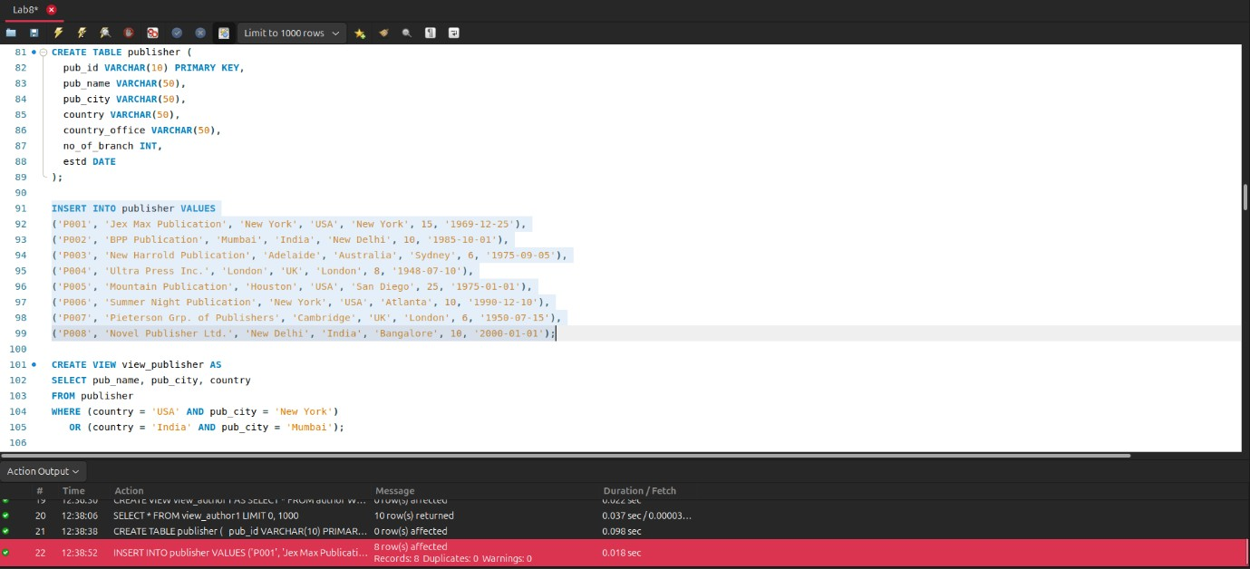
17.
CREATE VIEW view_publisher
AS SELECT pub_name,pub_city,country
FROM publisher
WHERE (country='USA' AND pub_city='New York')
OR
(country='India' AND pub_city='Mumbai');
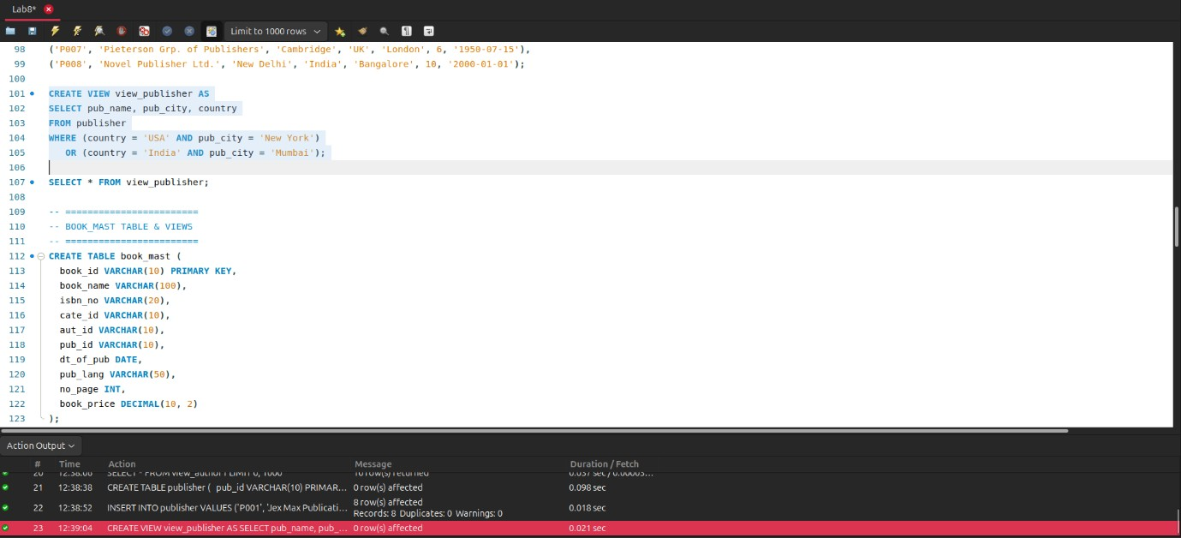
18.
SELECT * FROM view_publisher;
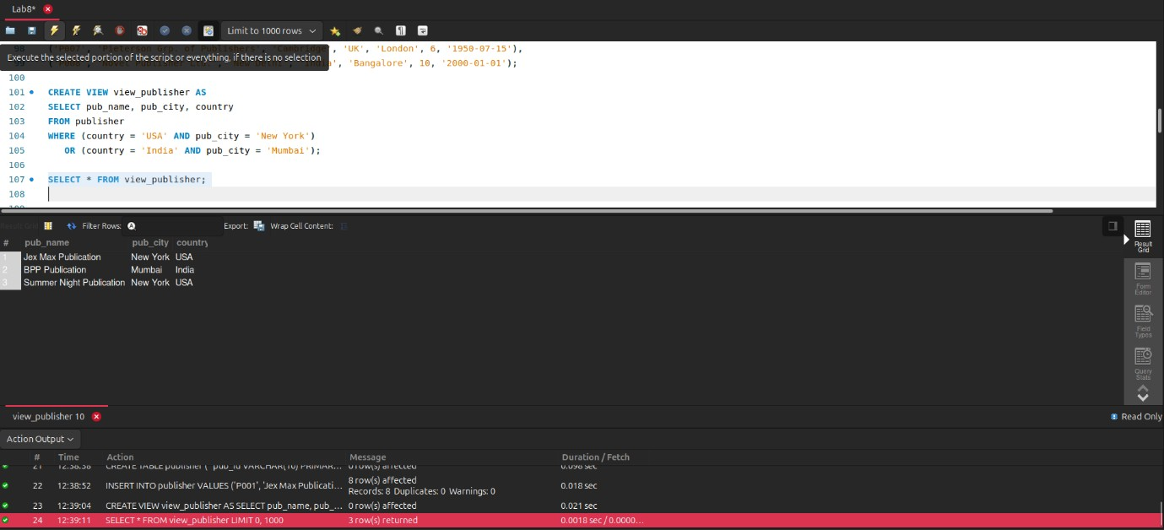
19. CREATE VIEW with GROUP BY CREATE TABLE book_mast ( book_id VARCHAR(10) PRIMARY KEY, book_name VARCHAR(100), isbn_no VARCHAR(20), cate_id VARCHAR(10), aut_id VARCHAR(10), pub_id VARCHAR(10), dt_of_pub DATE, pub_lang VARCHAR(50), no_page INT, book_price DECIMAL(10, 2)
);
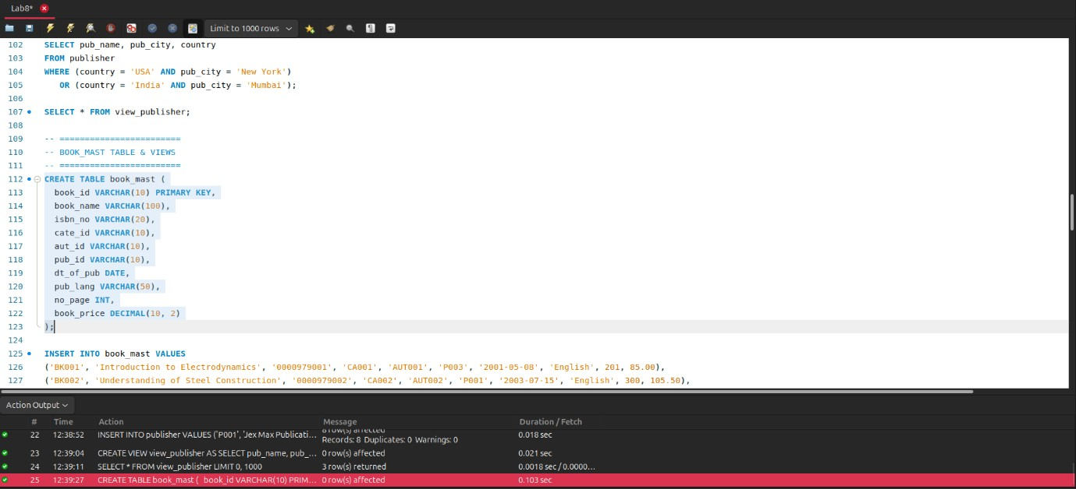
20.
INSERT INTO book_mast (book_id, book_name, isbn_no, cate_id, aut_id, pub_id,
dt_of_pub, pub_lang, no_page, book_price)
VALUES
('BK001', 'Introduction to Electrodynamics', '0000979001', 'CA001', 'AUT001', 'P003',
'2001-05-08', 'English', 201, 85.00),
('BK002', 'Understanding of Steel Construction', '0000979002', 'CA002', 'AUT002',
'P001', '2003-07-15', 'English', 300, 105.50),
('BK003', 'Guide to Networking', '0000979003', 'CA003', 'AUT003', 'P002', '2002-09-
10', 'Hindi', 510, 200.00),
('BK004', 'Transfer of Heat and Mass', '0000979004', 'CA002', 'AUT004', 'P004',
'2004-02-16', 'English', 600, 250.00),
('BK005', 'Conceptual Physics', '0000979005', 'CA001', 'AUT005', 'P006', '2003-07-
16', NULL, 345, 145.00),
('BK006', 'Fundamentals of Heat', '0000979006', 'CA001', 'AUT006', 'P005', '2003-08-
10', 'German', 247, 112.00),
('BK007', 'Advanced 3d Graphics', '0000979007', 'CA003', 'AUT007', 'P002', '2004-02-
16', 'Hindi', 165, 56.00),
('BK008', 'Human Anatomy', '0000979008', 'CA005', 'AUT008', 'P006', '200105-17',
'German', 88, 50.50),
('BK009', 'Mental Health Nursing', '0000979009', 'CA005', 'AUT009', 'P007', '2004-
02-10', 'English', 350, 145.00),
('BK010', 'Fundamentals of Thermodynamics', '0000979010', 'CA002', 'AUT010',
'P007', '2002-10-14', 'English', 400, 225.00),
('BK011', 'The Experimental Analysis of Cat', '0000979011', 'CA004', 'AUT011',
'P005', '2007-06-09', 'French', 225, 95.00),
('BK012', 'The Nature of World', '0000979012', 'CA004', 'AUT005', 'P008', '2005-12-
20', 'English', 350, 88.00),
('BK013', 'Environment a Sustainable Future', '0000979013', 'CA004', 'AUT012',
'P001', '2003-10-27', 'German', 165, 100.00),
('BK014', 'Concepts in Health', '0000979014', 'CA005', 'AUT013', 'P004', '2001-08-25',
NULL, 320, 180.00),
('BK015', 'Anatomy & Physiology', '0000979015', 'CA005', 'AUT014', 'P008', '2000-10-
10', 'Hindi', 225, 135.00),
('BK016', 'Networks and Telecommunications', '00009790_16', 'CA003', 'AUT015',
'P003', '2002-01-01', 'French', 95, 45.00);
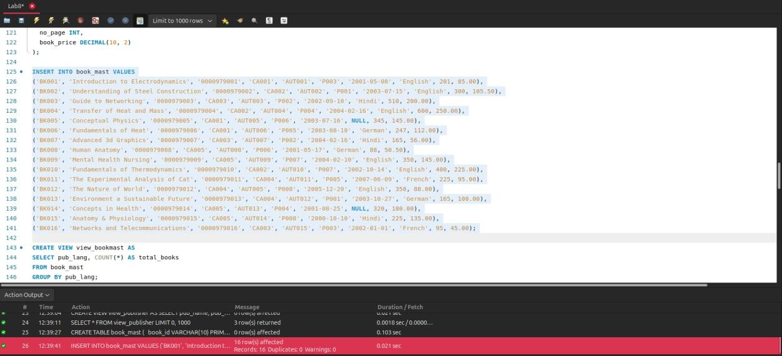
21.
CREATE VIEW view_bookmast
AS SELECT pub_lang, count(*)
FROM book_mast
GROUP BY pub_lang;
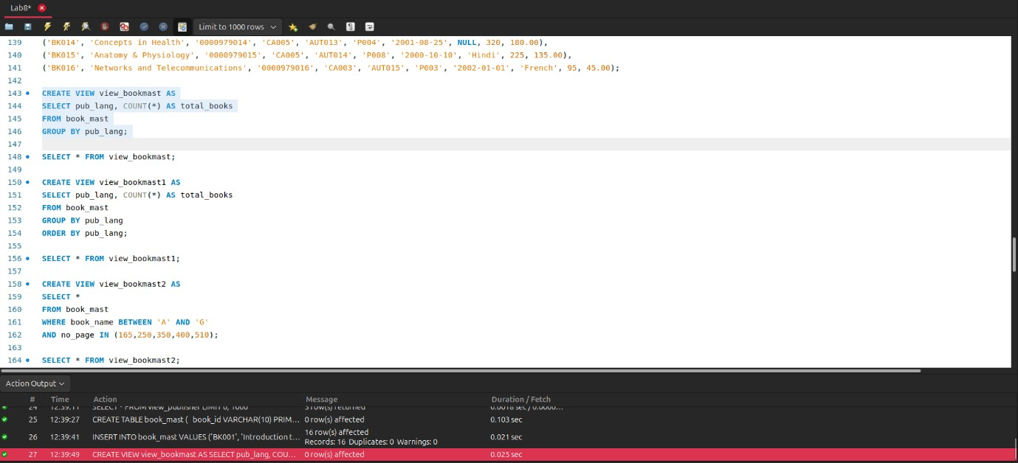
22.
SELECT * FROM view_bookmast;
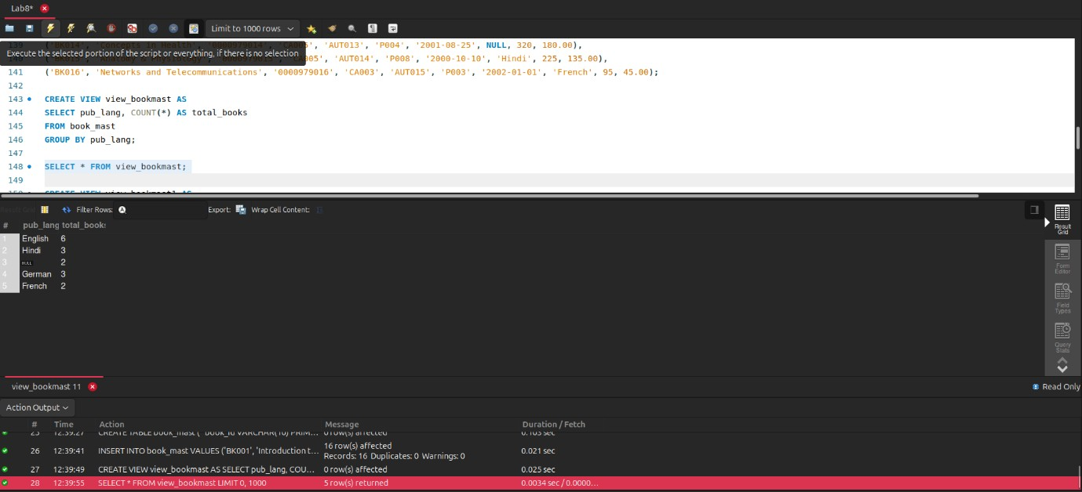
23. CREATE VIEW with ORDER BY CREATE VIEW view_bookmast1
AS SELECT pub_lang,count(*)
FROM book_mast1
GROUP BY pub_lang ORDER BY pub_lang;
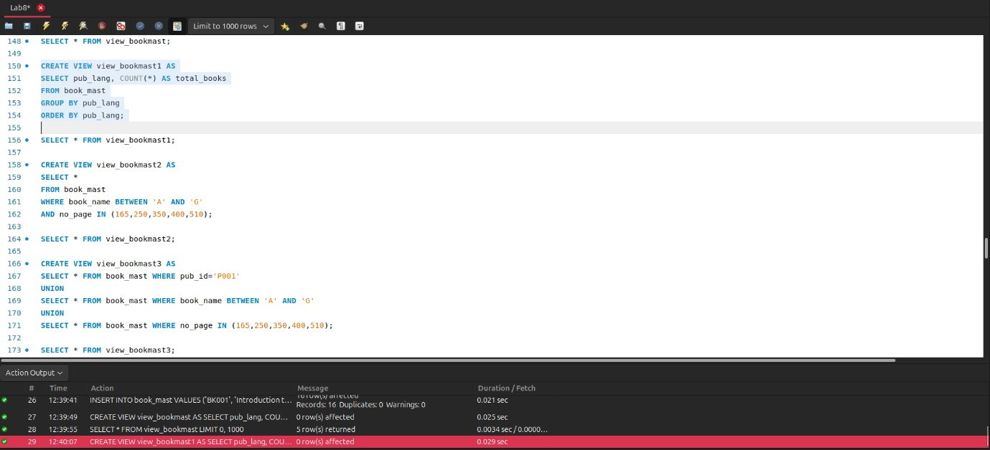
24.
SELECT * FROM view_bookmast1;
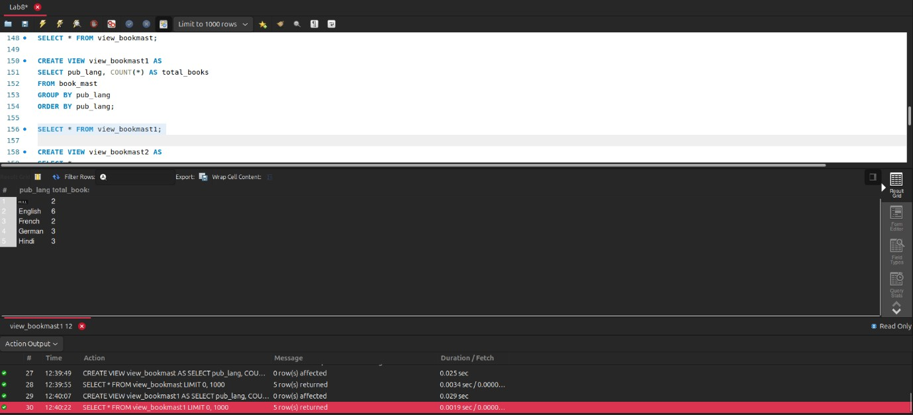
25. CREATE VIEW with BETWEEN and IN
CREATE VIEW view_bookmast2
AS SELECT *
FROM book_mast1
WHERE book_name BETWEEN 'A' AND 'G'
AND no_page IN(165,250,350,400,510);
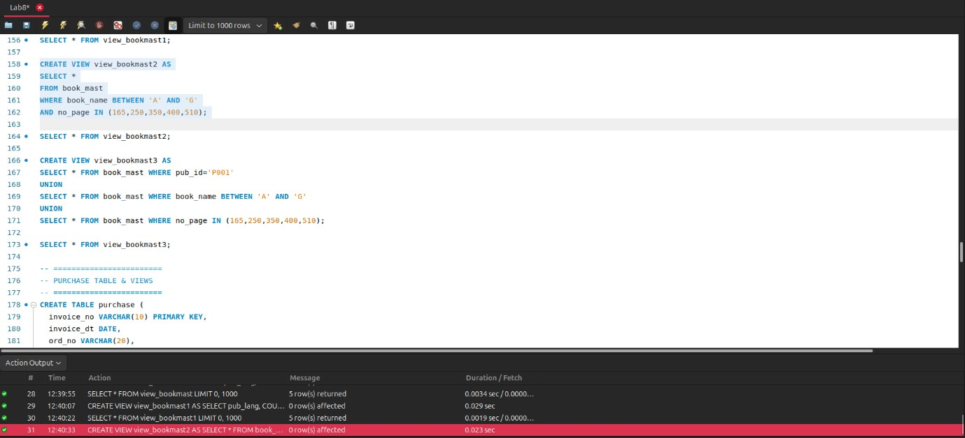
26.
SELECT * FROM view_bookmast2;
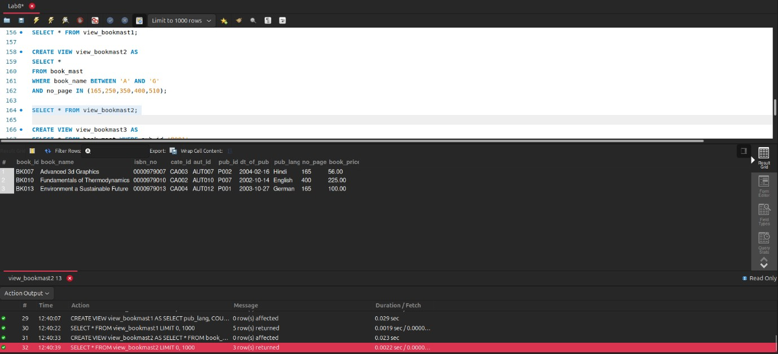
27. CREATE VIEW with LIKE
CREATE VIEW view_author1
AS SELECT *
FROM author1
WHERE aut_name
NOT LIKE 'T%' AND aut_name NOT LIKE 'W%';
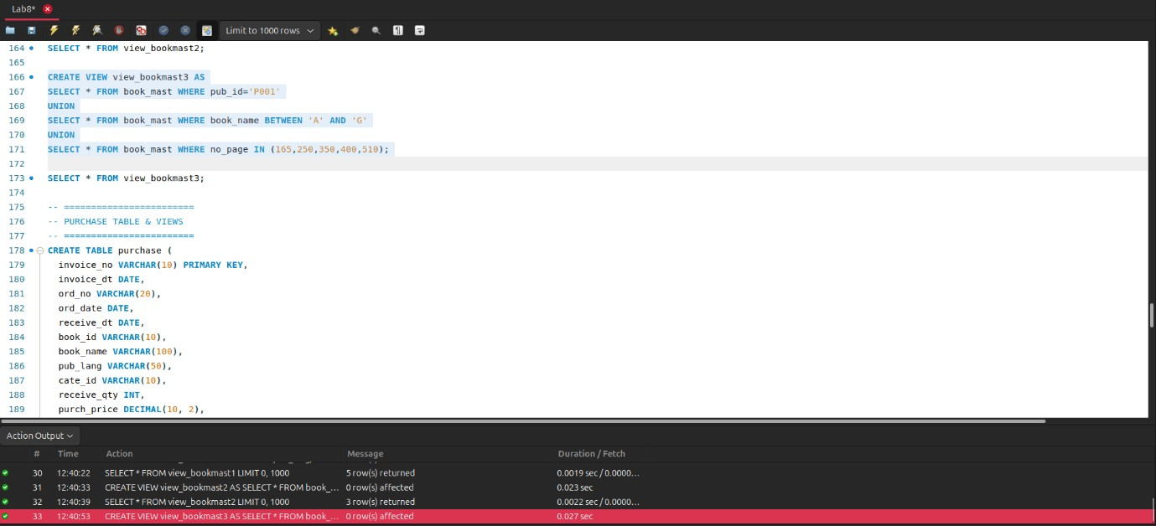
28.
SELECT * FROM view_author1;
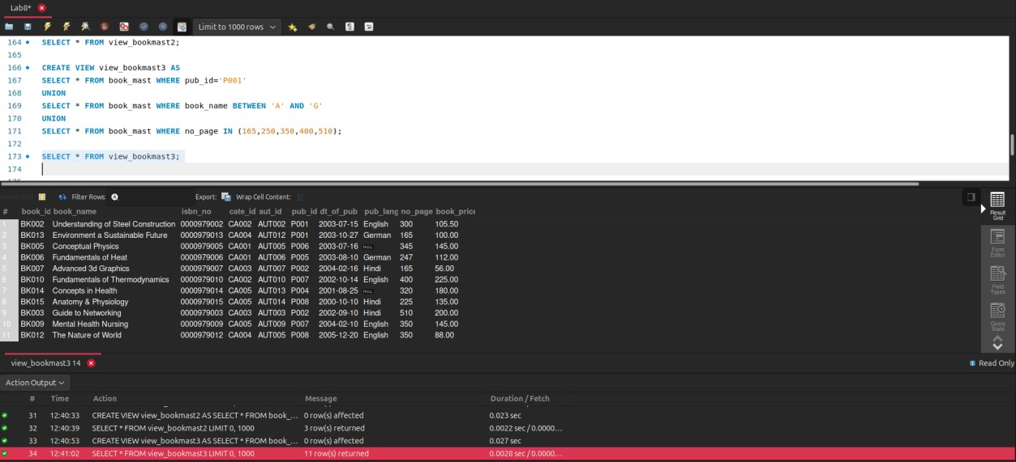
29. CREATE VIEW using subqueries CREATE TABLE purchase ( invoice_no VARCHAR(10) PRIMARY KEY, invoice_dt DATE, ord_no VARCHAR(20), ord_date DATE, receive_dt DATE, book_id VARCHAR(10),
book_name VARCHAR(100), pub_lang VARCHAR(50), cate_id VARCHAR(10), receive_qty INT, purch_price DECIMAL(10, 2), total_cost DECIMAL(10, 2)
);
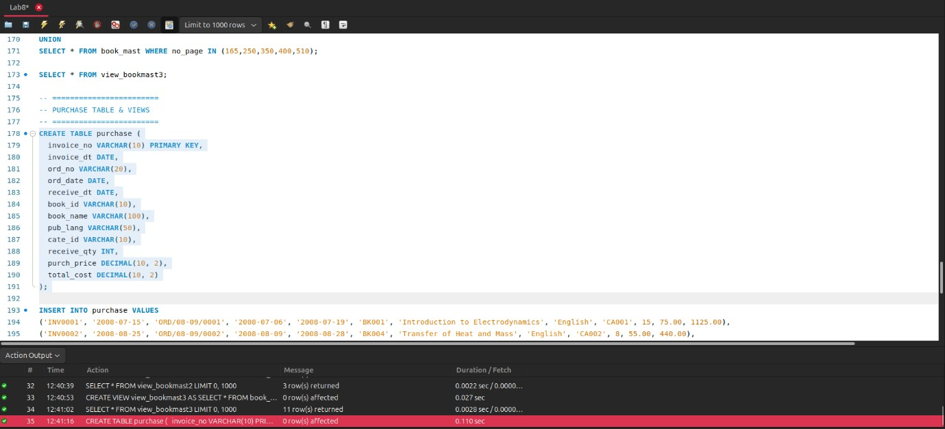
30.
INSERT INTO purchase (invoice_no, invoice_dt, ord_no, ord_date, receive_dt, book_id, book_name, pub_lang, cate_id, receive_qty, purch_price, total_cost)
VALUES
('INV0001', '2008-07-15', 'ORD/08-09/0001', '2008-07-06', '2008-07-19', 'BK001',
'Introduction to Electrodynamics', 'English', 'CA001', 15, 75.00, 1125.00),
('INV0002', '2008-08-25', 'ORD/08-09/0002', '2008-08-09', '2008-08-28', 'BK004',
'Transfer of Heat and Mass', 'English', 'CA002', 8, 55.00, 440.00),
('INV0003', '2008-09-20', 'ORD/08-09/0003', '2008-09-15', '2008-09-23', 'BK005',
'Conceptual Physics', NULL, 'CA001', 20, 20.00, 400.00),
('INV0004', '2007-08-30', 'ORD/07-08/0005', '2007-08-22', '2007-08-30', 'BK004',
'Transfer of Heat and Mass', 'English', 'CA002', 15, 35.00, 525.00),
('INV0005', '2007-07-28', 'ORD/07-08/0004', '2007-06-25', '2007-07-30', 'BK001',
'Introduction to Electrodynamics', 'English', 'CA001', 8, 25.00, 200.00),
('INV0006', '2007-09-24', 'ORD/07-08/0007', '2007-09-20', '2007-09-30', 'BK003',
'Guide to Networking', 'Hindi', 'CA003', 20, 45.00, 900.00);
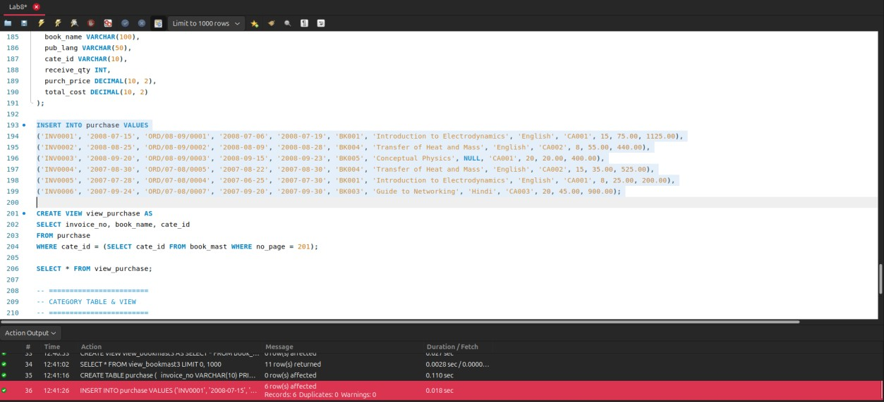
31.
CREATE VIEW view_purchase
AS SELECT invoice_no,book_name,cate_id
FROM purchase
WHERE cate_id= (SELECT cate_id FROM book_mast WHERE no_page=201);
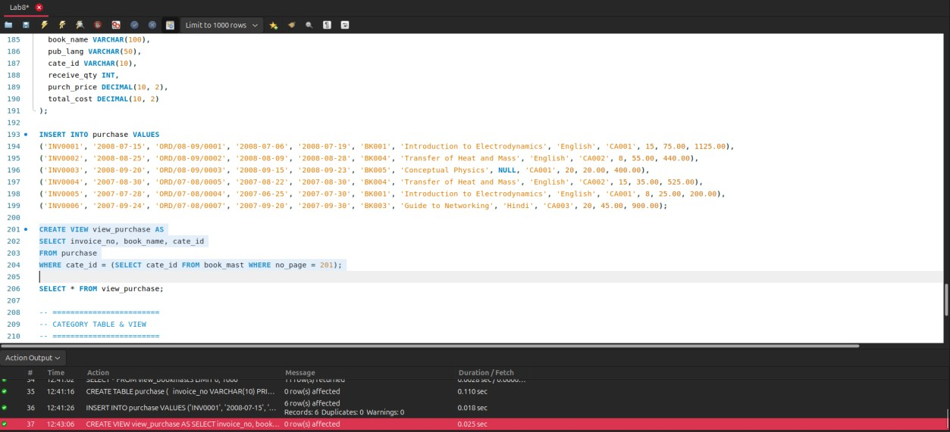
32.
SELECT * FROM view_purchase;
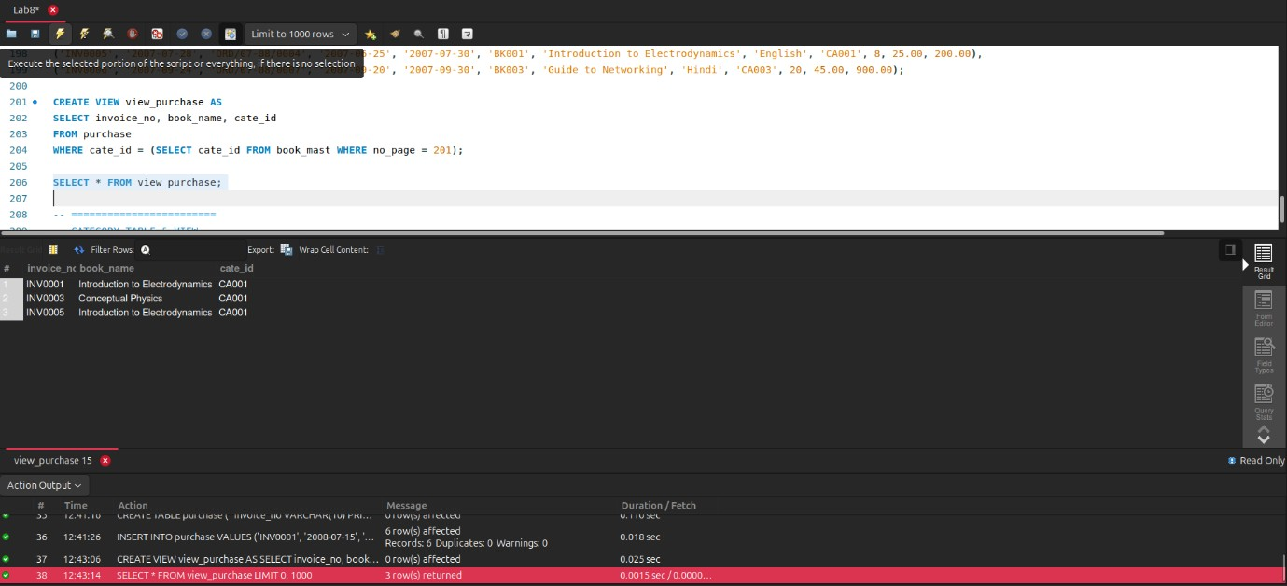
33. CREATE VIEW with JOIN CREATE TABLE category ( cate_id VARCHAR(10) PRIMARY KEY, cate_descrip VARCHAR(50)
);
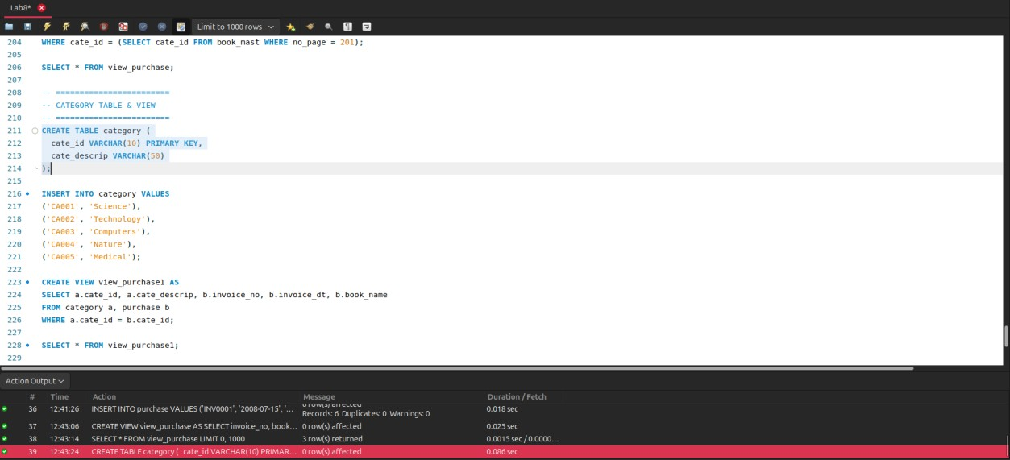
34.
INSERT INTO category (cate_id, cate_descrip)
VALUES
('CA001', 'Science'),
('CA002', 'Technology'),
('CA003', 'Computers'),
('CA004', 'Nature'),
('CA005', 'Medical');
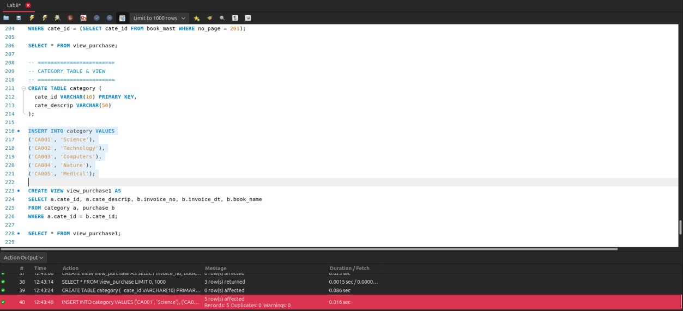
35.
CREATE VIEW view_purchase1
AS SELECT a.cate_id,a.cate_descrip, b.invoice_no, b.invoice_dt,b.book_name FROM category a,purchase b
WHERE a.cate_id=b.cate_id;
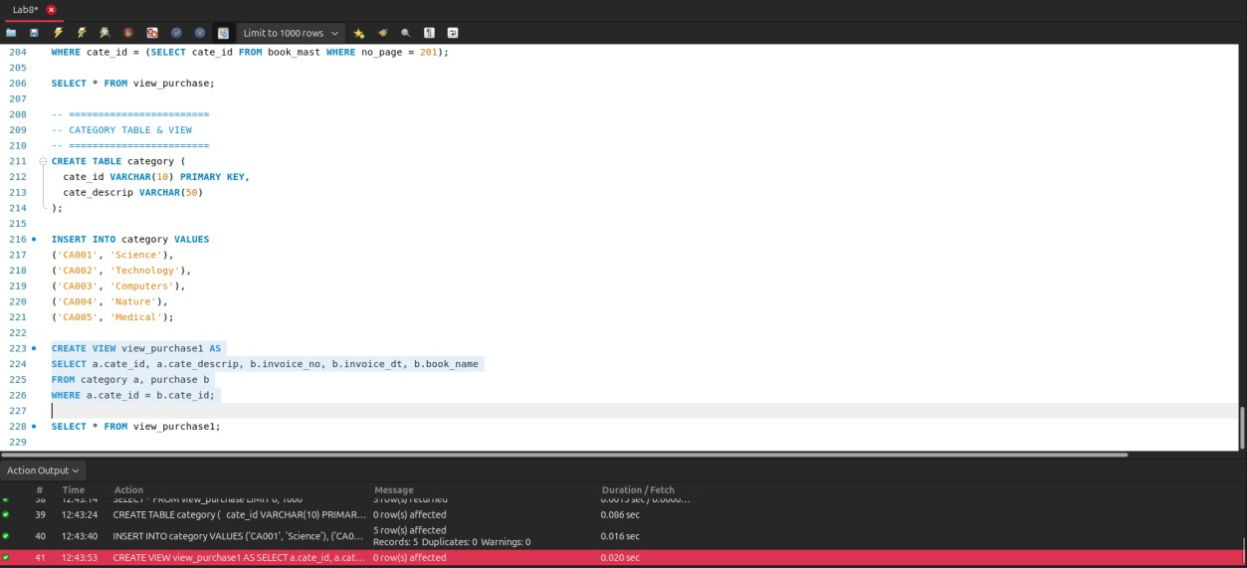
36.
SELECT * FROM view_purchase1;
